Measurement Protocol PAM

# General Information:

|  |  |  |
| --- | --- | --- |
| Test date: 11/09/19 | Date prev. test: | Test number: 1 |
| Tested by: Sarah Schoultz | PAM number: 22 | Installed at ant.: NA |
| Comments: | | |
|  | | |
|  | | |
|  | | |
| Known problems: Detectors broken | | |
|  | | |
|  | | |
|  | | |

# Setup:

|  |  |  |  |
| --- | --- | --- | --- |
| Power supply: | OK 🗹 NOK 🗆 | Communication: | OK 🗹 NOK 🗆 |
| Supply current +6V: 1.125mA | | ssh obs@antcntl | |
| Supply current -6V: 0.130mA | | ssh ataant@ant0 | pw: q@n@t |
| Supply current +5V: 0.188mA | | telnet pax | “help” |
|  | | CTRL + ] | “close” |

# RF Test with VNA:

### VNA Setup:

|  |  |  |
| --- | --- | --- |
| Load configuration: Passband_PAX.csa | | |
| Freq Start: 1.0 GHz | Freq Stop: 13.0 GHz | Power Level: -20 dBm |
| Averaging: enabled | Averaging count: 15 | N. Points: 801 |
| VNA : Agilent N5230C 10MHz - 20GHz | | |

|  |  |  |  |  |
| --- | --- | --- | --- | --- |
| VNA to PAX connection: | 1m ABC-CA18 Cable + 20dB Attenuator | | | |
| Input Power Level to PAX: (Measured) | @1GHz:  -40.2dBm | @4GHz:  -40.7dBm | @8GHz: -41.2dBm | @12GHz: -41.4dBm |

|  |  |
| --- | --- |
| PAX to VNA connection: | 2m Fibre Cable + Fibre Diode + AOX Amplifier + 1m ABC-CA18 Cable |

### Measured Passband with Attenuator set to 7dB each (Complete Link):

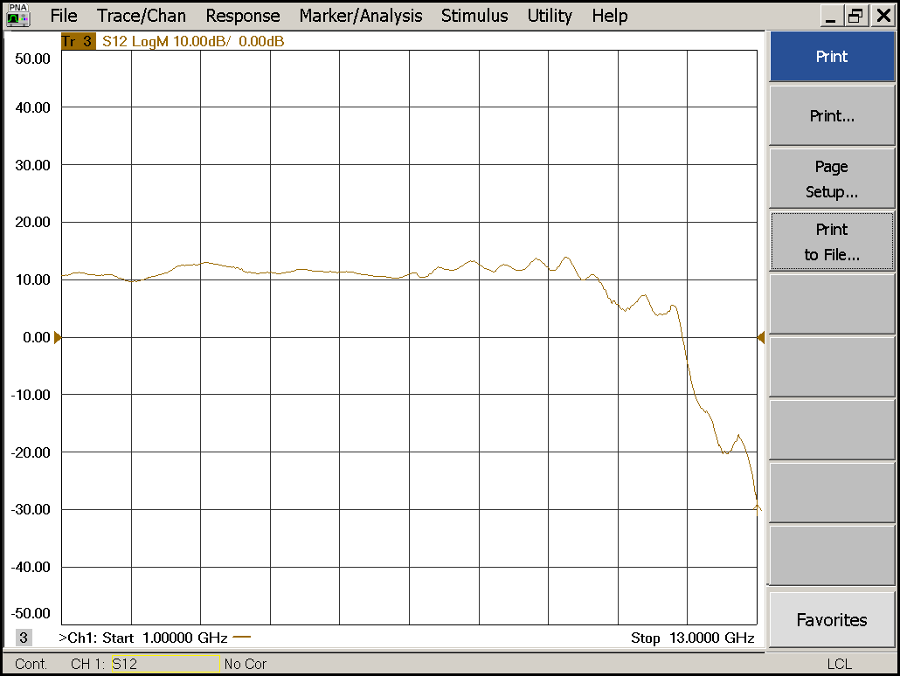

|  |  |  |  |
| --- | --- | --- | --- |
| Flatness: | OK 🗹 NOK 🗆 | Unwanted Features: | Yes 🗹 No 🗆 |

### Power Sweep (Complete Link):

|  |  |  |
| --- | --- | --- |
| Load configuration: Power_Sweep_PAX.csa | | |
| Power Start: -40dBm | Power Stop: -20dBm | Frequency : 4.0GHz |
| PAM Attenuator: 0dB |  | N. Points: 801 |

|  |  |  |  |
| --- | --- | --- | --- |
| Compression point: | OK 🗹 NOK 🗆 | Unwanted Features: | Yes 🗆 No 🗹 |

### Detector Calibration and Attenuator Sweep:

|  |  |  |
| --- | --- | --- |
| Load configuration: Detector_Calibration_PAX.csa | | |
| Freq : 4.0 GHz | Power Level: -20dBm | Sweep Time: -20sec |
| Sweep Mode: CW | Power Level at PAX Input (Measured): -40.6dBm | |

|  |  |  |  |  |
| --- | --- | --- | --- | --- |
|  | | | | |
| CW Input Power [dBm]: | Attenuator Value A [dB]: | Attenuator Value: B [dB]: | Detector Value: | Power Meter  Value [dBm]: |
| -40.6 | 0 | 0 | 0.0007 | 13.1 |
| -40.6 | 0 | 3 | 0.0007 | 13.2 |
| -40.6 | 0 | 6 | 0.0008 | 12.7 |
| -40.6 | 0 | 9 | 0.0007 | 10.4 |
| -40.6 | 0 | 12 | 0.0007 | 7.5 |
| -40.6 | 0 | 15 | 0.0007 | 4.7 |
| -40.6 | 0 | 18 | 0.0007 | 1.4 |
| -40.6 | 0 | 21 | 0.0007 | -1.6 |
| -40.6 | 3 | 21 | 0.0008 | -5.1 |
| -40.6 | 6 | 21 | 0.0008 | -8.1 |
| -40.6 | 9 | 21 | 0.0007 | -11.1 |
| -40.6 | 12 | 21 | 0.0008 | -14.0 |
| -40.6 | 15 | 21 | 0.0007 | -17.0 |
| -40.6 | 18 | 21 | 0.0007 | -20.2 |
| -40.6 | 21 | 21 | 0.0007 | -23.3 |
| -40.6 | 24 | 21 | 0.0007 | -26.2 |
| -40.6 | 27 | 21 | 0.0007 | -29.2 |
| -40.6 | 30 | 21 | 0.0008 | -32.3 |
| -40.6 | 30 | 24 | 0.0007 | -35.0 |
| -40.6 | 30 | 27 | 0.0007 | -37.4 |
| -40.6 | 30 | 30 | 0.0007 | -39.6 |

|  |  |  |
| --- | --- | --- |
| Use Noise Source: Atlantic AS6333 | | |
| Freq : 1.0 - 12.0GHz | Power Level: -41.8dBm |  |
| DC Supply: 28V |  | |

|  |  |  |  |  |
| --- | --- | --- | --- | --- |
|  | | | | |
| CW Input Power [dBm]: | Attenuator Value A [dB]: | Attenuator Value: B [dB]: | Detector Value: | Power Meter  Value [dBm]: |
| -41.8 | 0 | 0 | 0.0010 | 11.7 |
| -41.8 | 0 | 3 | 0.0011 | 10.9 |
| -41.8 | 0 | 6 | 0.0011 | 9.6 |
| -41.8 | 0 | 9 | 0.0011 | 7.8 |
| -41.8 | 0 | 12 | 0.0011 | 5.3 |
| -41.8 | 0 | 15 | 0.0010 | 2.9 |
| -41.8 | 0 | 18 | 0.0010 | -0.2 |
| -41.8 | 0 | 21 | 0.0010 | -3.1 |
| -41.8 | 3 | 21 | 0.0010 | -6.1 |
| -41.8 | 6 | 21 | 0.0011 | -9.2 |
| -41.8 | 9 | 21 | 0.0010 | -12.1 |
| -41.8 | 12 | 21 | 0.0011 | -15.1 |
| -41.8 | 15 | 21 | 0.0011 | -17.7 |
| -41.8 | 18 | 21 | 0.0011 | -21.0 |
| -41.8 | 21 | 21 | 0.0010 | -24.1 |
| -41.8 | 24 | 21 | 0.0010 | -27.0 |
| -41.8 | 27 | 21 | 0.0010 | -29.8 |
| -41.8 | 30 | 21 | 0.0011 | -33.0 |
| -41.8 | 30 | 24 | 0.0010 | -35.6 |
| -41.8 | 30 | 27 | 0.0010 | -37.7 |
| -41.8 | 30 | 30 | 0.0010 | -39.9 |